Basic Concepts of DNA, DNA Tests and Genetic Genealogy

- Types of DNA used in Genetic Testing
- mtDNA (Mitochondrial DNA) Passed from mother to daughter revealing the maternal line.
- Y-DNA (Y – Chromosomal DNA) Only men have a Y chromosome. Passed from father to son to reveal the paternal line.
- atDNA (Autosomal DNA) Reveals information from both paternal and maternal lines.
- X-DNA (X – Chromosomal DNA) Focuses on the 23rd or X chromosome. X-DNA is a subset of atDNA. It can get very complicated. It is subject to rapid changes.
- DNA Genetic Makeup
- Each person is unique. Each cell contains:
- 22 sets of paired autosomal chromosomes
- 1 paired sex chromosome
- Rings of mtDNA (Mitochondria is outside the nucleus)
- Imagine a fried egg. Chromosomes are in the yolk, mitochondria is in the white.
- Mitochondrial – DNA (mtDNA).
- Maternal line.
- HVR1 & HVR2 (Hypervariable Control Regions 1&2)
- HVR1 & HVR2 are fast changing.
- CR (Coding Region)
- Your mtDNA test should include the full range mtDNA sequence including the HVR1, HVR2, and CR. You get much better detail and information.
- mtDNA is passed down as an exact copy of the DNA without recombination (mixing of DNA) from mother to child (both male and female).
- While the daughter and son get this mtDNA, only the daughter passes it on to the next generation.
- Do not confuse this with X-DNA. Both deal with the maternal line, but X-DNA is within atDNA.
- Tested by “Family Tree DNA” and “Living DNA”.
- Y-Chromosomal (Y – DNA).
- The Y chromosome is one of two sex chromosomes in the nucleus of every cell.
- It is found only in men.
- The Y chromosome is always passed from the father to the son.
- If a man has only daughters, his Y–DNA stops.
- The son’s Y chromosome will almost always be identical to the father. (Small mutations take place over time.)
- Y-DNA allows genealogists to trace this piece of DNA forward and backwards in a family tree.
- Women must use a male family member to trace the Y chromosome.
- Tested by “Family Tree DNA” and “Living DNA”.
- Y-Chromosomal (Y – DNA). Y-STR and Y-SNP.
- Y-STR (Short Tandem Repeat) and Y-SNP (Single Nucleotide Polymorphism) tests (similar to the mtDNA Haplogroups) provide a Haplotype (sometimes also called a Haplogroup) that tells how closely related two men are to each other.
- The more similar the STR’s and SNP’s, the closer related you are. The more STR’s and SNP’s tested, the more refined and accurate of an assessment can be made.
- Autosomal – DNA (atDNA). Testing by “Ancestry”, “MyHeritage”, “23andMe”, “FTDNA”, and “Living DNA”.
- atDNA is usually done for cousin matching and ethnicity estimates.
- atDNA will include any X–DNA data.
- atDNA is inherited from both parents as they did from their parents. Statistically, this is a 50-50 inheritance but it actually varies.
- Each child inherits half of each parent’s DNA. Siblings will not always inherit the exact or same DNA.
- Autosomal DNA refers to the 22 pairs of non-sex chromosomes found in every cell’s nucleus.
- atDNA is the most common test.
- Autosomal DNA varies in length with the first chromosome being the longest and 22nd being the shortest (for the most part).
- Genealogical siblings, cousins, etc. may not share the same segments of their ancestor’s DNA.
- You will not get DNA from all of your ancestors.
- Each generation of DNA inheritance drops by about 50% from the previous one.
- Each testing company has its own threshold for determining genetic relationships.
- The larger the cM’s and number of shared segments found in a match mean a closer relationship.
- Fewer cM’s and shared segments mean many generations between you and a genetic match.
- The shared DNA helps researchers determine which part of the chromosome was inherited from other ancestors.
- Autosomal – DNA (atDNA) Tests.
- The “Big Three” are Ancestry, Family Tree DNA, and 23andMe.
- Living DNA has a new chip that will challenge them. (“More details and more precise DNA.”)
- MyHeritage has a smaller presence.
- Each testing company has its own threshold for determining genetic relationships.
- Autosomal – DNA (atDNA) Recombination.
- Recombination is also called genetic reshuffling.
- Some chromosomes are randomly altered during conception.
- The result is an offspring with a combinations of traits that differ from those found in either parent and usually relates to their grandparents.
- Ancestry’s cM Possible Relationship Chart.
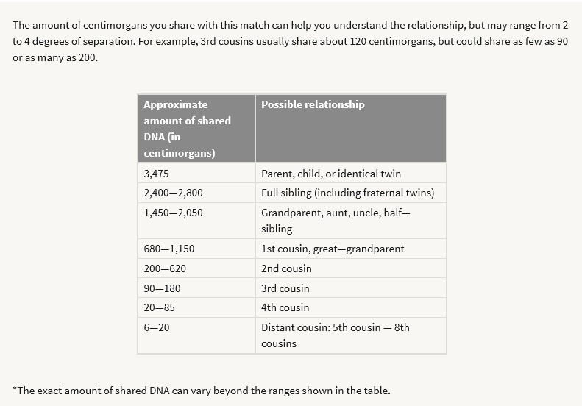

- X-DNA.
- X-DNA is a subset of atDNA.
- X-DNA is not mtDNA. X-DNA resides in the nucleus of each cell. mtDNA resides outside the nucleus.
- Look for shared segments of 20cM or more.
- X-DNA can change rapidly from one generation to the next.
- It can become very difficult to understand and place a match in your genealogical tree.
- There are different rules for males and females concerning possible inheritance of X-DNA.
- Possible X-Chromosomal DNA Inheritance Rules – Male.
- The male receives a Y chromosome from his father and an X chromosome from his mother.
- A father passes down his X-DNA only to his daughter(s).
- If a father has no daughter(s), his X-DNA line stops.
- Possible X-Chromosomal DNA Inheritance Rules – Female.
- The female gets an X chromosome from her mother (allowing you to trace the maternal line) and another X chromosome from her father.
- A mother always passes down an X chromosome to each child.
- A mother may pass down unchanged X chromosomes, but sometimes she will pass down a mixed or recombined X chromosome. In this case the child will inherit traits from both maternal grandmothers.

- Possible X-DNA Inheritance Charts.
- Male possible X-DNA inheritance.

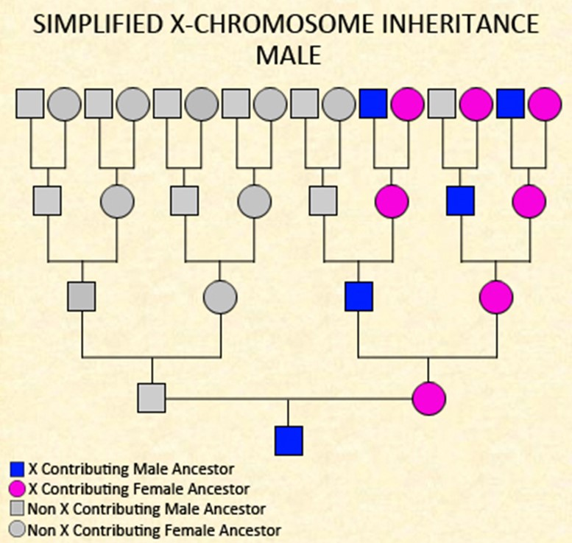
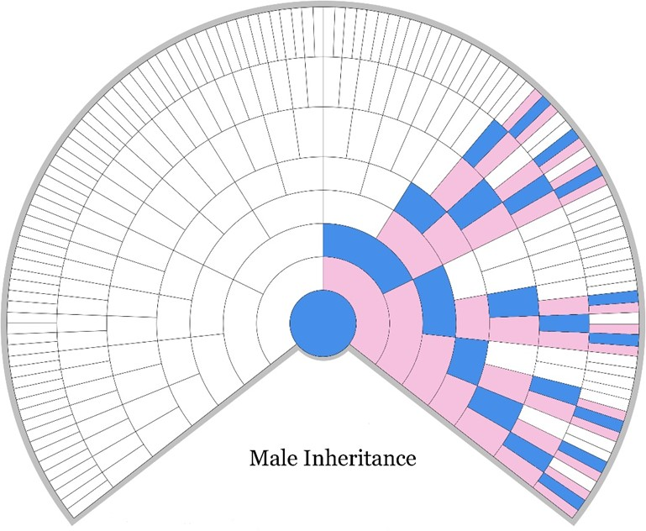

- Female possible X-DNA inheritance.
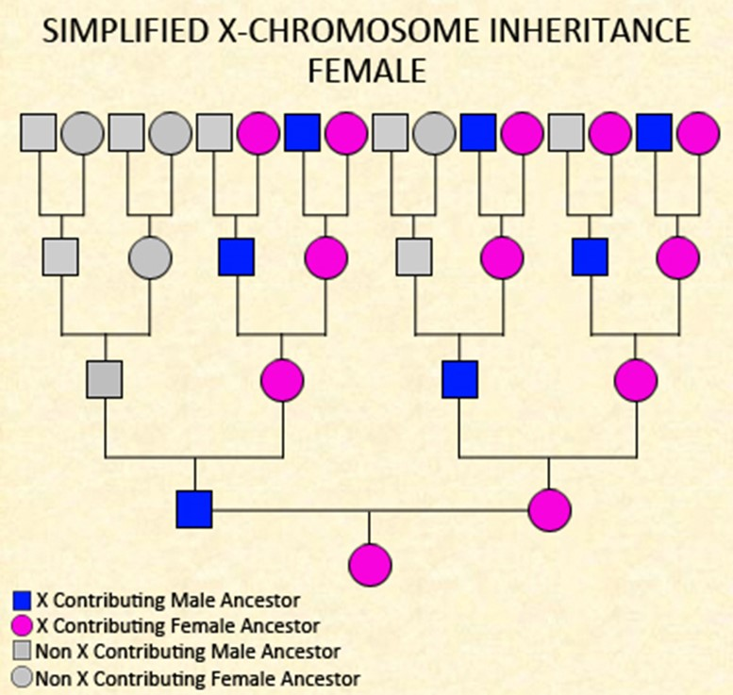
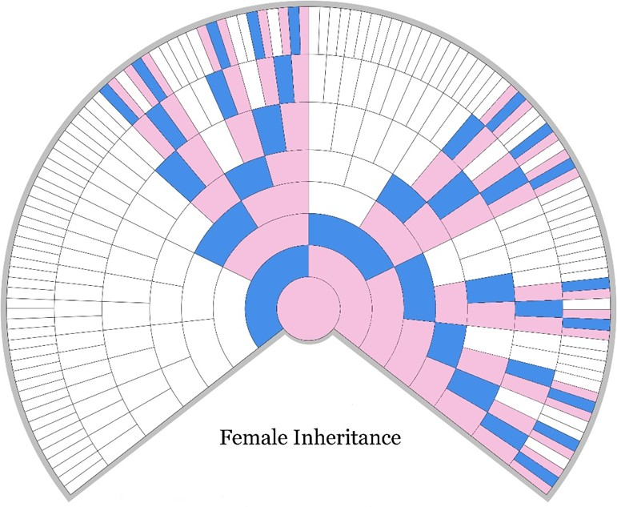

- How Can X-DNA Test Results Impact Genealogical Research.
- An atDNA match does not guarantee an X-DNA match.
- If you look at the possible X-DNA inheritance rules and charts, that may help place the X-DNA match into your genealogical tree.
- A genetic match with only a very small segment may be a false positive and not lead to a common ancestor.
- Look for shared X-DNA segments of at least 20 cM.
- The Shared cM Project.
- “The Shared cM Project” provides charts that show estimated cM length and percentages compared to your relationship to other people. I prefer the older versions (June 2016) that include percentages and cM length because 23andMe uses percentages while other testers use only cM length to show relationships.
- These charts will help determine how many generations separate you from another person.
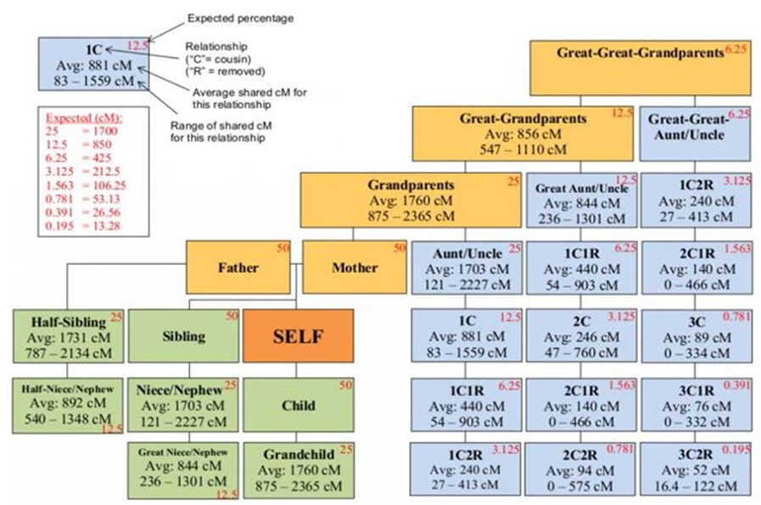
- 2015 chart. https://thegeneticgenealogist.com/2015/05/29/visualizing-data-from-the-shared-cm-project/

- 2017 chart. https://dnapainter.com/tools/sharedcmv4
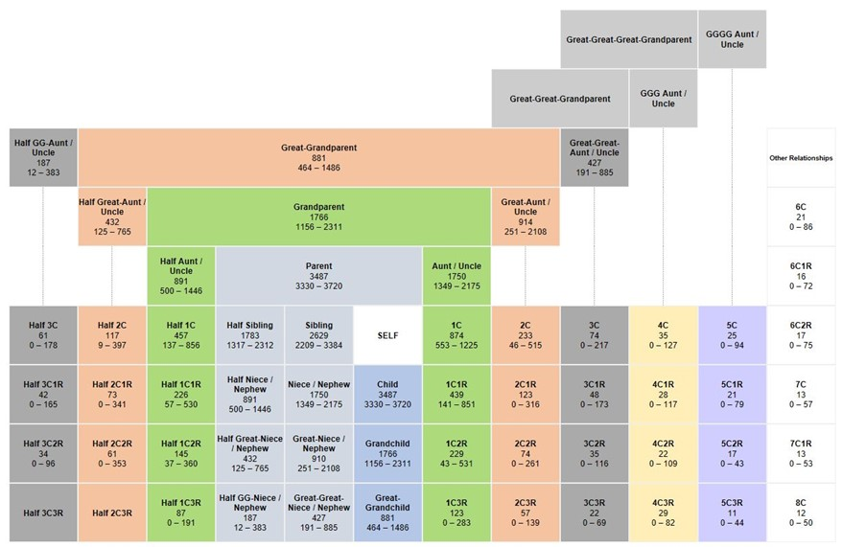

- Useful Reference Data to Print and Have Handy While Reviewing DNA Matches.
- X – DNA inheritance rules for males and females.
- X – DNA inheritance charts for males and females.
- Shared cM Project charts (old and new versions).
- A Guide to Placing X-DNA Matches in Your Genealogical Tree.
- Ancestry cM possible relationship chart.

- Genetic Trees vs. Genealogical Trees.
- Some genealogical software programs for your home computer are now making adaptations to show DNA/genetic connections with members of your genealogical tree.
- Genetic trees show those ancestors who have provided DNA to you.
- Genealogical trees contain those people who are your known ancestors and relatives.
- Genetic trees will not show everyone on your genealogical tree because you do not receive DNA from all of your ancestors and relatives.

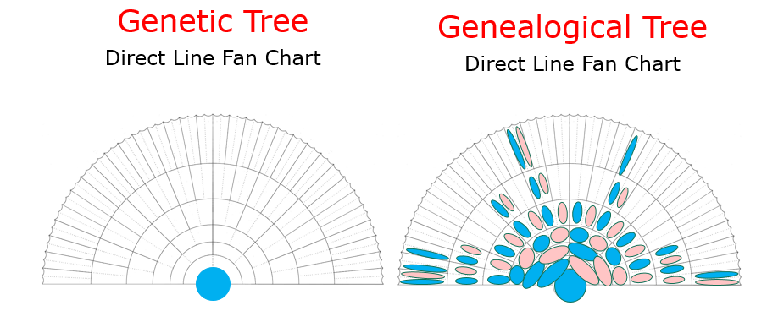
- Types of DNA and Testing Companies.

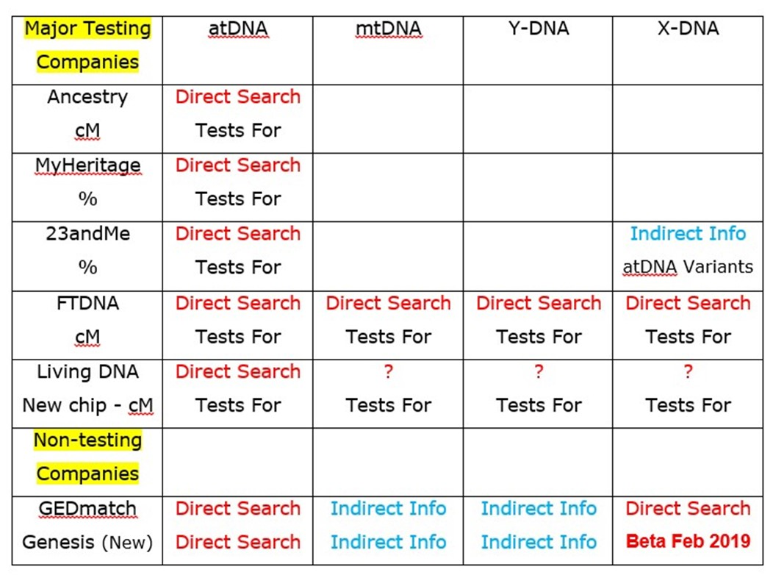

- Ancestry autosomal tools.
- Once you have signed into Ancestry, hover over “DNA”, and then choose “Your DNA Results Summary” from the drop down menu.
- “ThruLines”.
- Using the public or private searchable tree linked to your Ancestry DNA test, they search for people who appear in both your tree and other Ancestry member trees that are marked as public or private searchable. ThruLines uses this information to illustrate how you and your DNA matches might be related through common ancestors.
- ThruLines may also suggest potential ancestors.
- Your DNA matches are also labeled with how many centimorgans (cM) of DNA you share and the relationships that are possible between you.
- 23andMe. (New web pages.)
- Hover over “Ancestry” or “Family & Friends” and then Select “DNA Relatives”.
- Since this is a new homepage, some tools are still in development and do not function at this time.
- Hover over “Family & Friends” and then Select “DNA Comparison”.
- No direct search for X-DNA matches. You must search every match and look at the shared DNA chromosomes.
XXII. Family Tree DNA (FTDNA).
- Autosomal tools found under “Family Finder” on their home page.
- Matches.
- Chromosome Browser.
- Matrix.
- Advanced Matches.
- Y-DNA tools found on their home page.
- Matches.
- Other tools.
- Projects. Based on surname of geographic area.
XXIII. Surname projects not in FTDNA.
- Search for “ ‘Your’ Surname DNA Project” to identify relevant projects.
- www.worldfamilies.net/surnames
- www.cindislist.com/surn-dna.htm
XXIV. Third party companies.
- They do not test.
- Third party programs allow you to compare your DNA with others not in your testing company’s database.
- GEDmatch/Genesis.
- GEDmatch/Genesis is the most popular and easiest to use. However, this may not be the best choice for you.
- Free program and the important tools are free. Tier One tools cost $10 per month.
- Easy to upload your raw DNA data from Ancestry, FTDNA, 23andMe, and others.
- In mid-December, GEDmatch started requiring all new uploads go to Genesis. Start thinking “Genesis”.
- This is an open, public data base. Anyone can search and use the data without a court order.
XXV. Transferring raw DNA data.
- This is a 2 step process.
- Download your raw DNA data from your testing company and save the file on your desktop.
- Use your favorite search engine and search “How to download raw DNA data from …”. Then follow the directions.
- FTDNA offers this service from their home page. “Download Raw Data”.
- Upload your raw DNA data to GEDmatch/Genesis, FTDNA, MyHeritage, or Living DNA.
- Search “How to upload raw DNA data into …” and follow the directions.
- For Living DNA go to http://whoareyoumadeof.com/blog/2018/08/14/upload-dna-to-living-dna-time-sensitive/
- For GEDmatch/Genesis go to their home page and use their upload link.
- Genetic Genealogical Standards.
- Go to http://www.thegeneticgenealogist.com/wp-content/uploads/2015/01/Genetic-Genealogy-Standards.pdf
- Genealogists and testing companies respect the privacy of the tester, however, once the results are publicly available they can freely accessed, copied and analyzed by a third party.
- Ethical Considerations.
- DNA tests for adoptees open a wide range of possibilities such as acceptance (or not) by biological parents, how to make any contacts, privacy of those not tested, etc.
- Donor conception offers the same considerations as adoptees, but also the donors may have been promised anonymity.
- Genetic Exceptionalism is the belief that genetic information is unique and needs to be treated differently than typical genealogical paper research that is typically in PUBLIC databases.
- DNA testing can reveal family secrets (old and new) such as “parents” and biological parents may not be the same.
- DNA tests may be a way around some state laws that seal adoption records. Why were the records sealed?

- Resources.
- DNAAdoption - www.dnaadoption.com has lots of tools and information for everyone, not just adoptees.
- The DNA Detectives Facebook page – www.facebook.com/groups/DNADetectives is the largest community of adoptees and adoption/search angels using DNA.
- DNAAdoption Yahoo Group www.groups.yahoo.com/group/DNAAdoption
- ISSOGG DNA-NEWBIE List (International Society of Genetic Genealogy) www.groups.yahoo.com/group/DNA-NEWBIE/info
- Rootsweb Genealogy-DNA Mailing List www.lists.rootsweb.ancestry.com/index/other/DNA/GENEALOGY-DNA.html
- Unknown Fathers DNA Yahoo Group www.groups.yahoo.com/group/UnknownFathersDNA
- Books.
- “The Family Tree Guide to DNA testing and Genetic Genealogy” by Blaine T. Bettinger
- “Genetic Genealogy in Practice” by Blaine T. Bettinger and Debbie Parker Wayne
- “Jump into Genetic Genealogy: Use Genealogical DNA testing to Solve Family Mysteries” by FamilyTree University. A free downloadable e-book found at https://www.familytreemagazine.com/freebie/jump-into-genetic-genealogy-use-genealogical-dna-testing-to-solve-family-mysteries/ (Just Google the name.)
- “NextGen Genealogy: The DNA Connection” by David R. Dowell
- “Genetic genealogy: The Basics and Beyond” by Emily D. Aulicino
- Blogs.
- www.blog.23andme.com
- www.blogs.ancestry.com.ancestry/category/dna
- www.cruwys.blogspot.com (by Debbie Kennett)
- www.debsdelvings.blogspot.com (by Debbie Parker Wayne)
- www.dna-explained.com (by Roberta Estes)
- www.blog.ddowell.com (by David R. Dowell)
- www.thegeneticgenealogist.com (by Blaine Bettinger)
- General areas.
- ISSOGG Wiki (International Society of Genetic Genealogy) www.issogg.org/wiki/Wiki_Welcome_Page (The two underscores near the end appear as spaces.)
- Many different forms can be found by using your computer search engine. Most are not DNA specific.
- DNA testing company websites
- Google, Bing, Firefox, IE, Google Chrome, etc.
- Raw data transfer chart URL
- https://i2.wp.com/dna-explained.com/wp-content/uploads/2017/04/transfer-summary-sept-2017.png?ssl=1

A Guide to Placing X-DNA Matches in Your Genealogical Tree
- General
- You can attribute X segments to particular grandparents by comparing your X-DNA with cousins and other close relatives from each side of your family.
- Focus on larger segments of 20cM or more. Smaller segments may not be reliable.
- Mitochondrial DNA is not the same as X DNA. mtDNA is inherited maternally. Mothers give their mtDNA to all her children. mtDNA is not part of the 23 paired chromosomes. It surrounds the nucleus of each cell.
- The X chromosome does recombine when it can, or at least has the capacity to do so. This means that a female who receives an X from both her father and mother receives a recombined X from her mother, but receives an X that is not recombined from her father. In the mother, the X recombines “in the normal way” meaning that parts of both her mother’s and her father’s X are given to her children, or at least that opportunity exists.
- X DNA can define maternal and paternal lines for females. Cousins may be separated into maternal and paternal lines.
- Adoptees may use X-DNA as a tool to help identify their biological mother, siblings, and/or half siblings.
- People who must share X-DNA include a mother and her children, a father and his daughters, and sisters who have the same father.
- Females
1. A daughter will share a whole X chromosome with her father.
2. Full sisters will share a whole X chromosome, from their father.
3. Half-sisters will share a whole X chromosome if they have the same father.
4. Fathers contribute their whole X DNA to their daughters.
5. If a female has an X DNA match, the shared ancestor must come from the female inheritance pattern.
6. If half-sisters with the same mother share most of their X-DNA, they would have inherited it either from the same maternal grandparent, or the same or very similar recombined X.
7. The X chromosome does recombine when it can, or at least has the capacity to do so.
This means that a female receives an X from her father and a recombined X from her mother, with traits from her maternal grandmother and great-grandmother.
8. If half-sisters with the same mother share very little X-DNA with each other, one would have inherited most of her X from her mother's father and the other would have inherited most of her X from her mother's mother, or they each inherited the exact opposite of a recombined X.
- Mothers
1. The X chromosome does recombine when it can, or at least has the capacity to do so. In the mother, the X recombines “in the normal way” meaning that parts of both her mother’s and her father’s X are given to her children, or at least that opportunity exists.
- Males
1. If a male shares X-DNA with a match, then the ancestor in common will be on his mother's ancestral lines, according to the X inheritance patterns in the 'Male' chart.
2. All of a male’s X DNA comes from his mother.
3. If a male has as an X DNA match, the shared ancestor must come from the male X DNA inheritance pattern (maternal ancestral line).
4. If brothers share very little X-DNA with each other, one would have inherited most of his X from his mother's father and the other would have inherited most of his X from his mother's mother, or they inherited the exact opposite of a recombined X.
5. If brothers share most of their X-DNA, they would have inherited it either from the same maternal grandparent, or the same or very similar recombined X from both maternal grandparents.
- Fathers
1. A daughter will share a whole X chromosome with her father.
2. Full sisters will share a whole X chromosome, from their father.
3. Half-sisters will share a whole X chromosome if they have the same father.
4. Fathers contribute their whole X DNA to their daughters.
- Siblings
1. If siblings have tested their autosomal DNA, and a brother has X-matches in common with his sister(s), then the sisters will know that those particular X-matches must have come from their mother, as their brother could only have inherited them from their mother.

